Lab Session: 01

Name:Nabin Kumar Sah

Reg no.:-BL.EN.U4CSE21129

1.Discuss the importance of rank of an observation matrix in model building for classification.

The rank of an observation matrix is an important concept in model building for classification and machine learning task.It is very importantin machine learning in understanding the data , designing the models and ensuring their effectiveness.

Independence of features:-The features that is used to describe each observation are nearly independent in classification.The low rank of the observation matrix indicates that some featureas are linear combination of others.This lead to multicollinearity issue that leads to unstable model estimates.

Improved model performance :-lowering the rank of the matrix can improve the stability of the algorithm.

Enhancing model performance:-;Observation matrix having the low rank can lead to the improved model performance . It removes the irrevalent information and the noise from the dataset.

Computional efficiency:-Model with low rank leads to the more efficient training and prediction processes, that help in making the model building processes more practical.

From the given purchase data, we can find that the dimensional of the vector space and the rank of the given data set is (10,5) and 3 respectivelly.

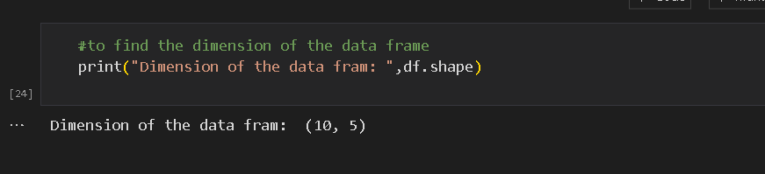

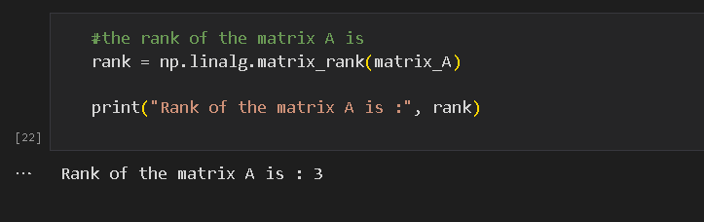

2. discussion regression(Ex:A2) and classification (Ex:A3)tasks. How would you differentiate between them?

Regression and classification are two types of the supervised machine learning that helps in predicting the outcomes.

Regression predicts a continuous range output while classification involves the assiging the discrete category.

In Ex:A2, we are calculating the cost of the each product availabe for the vendor.

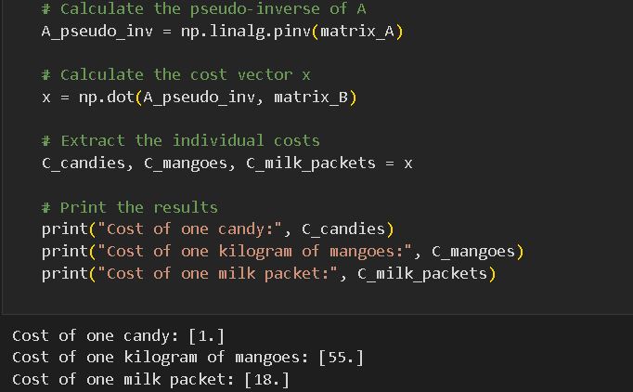

However in the Ex3 we are categorizing the customers in terms of the rich and poor .As per the question , if the payment is more or equal to 200 then that customer are categorized as rich and the customer below that is categorized as poor.

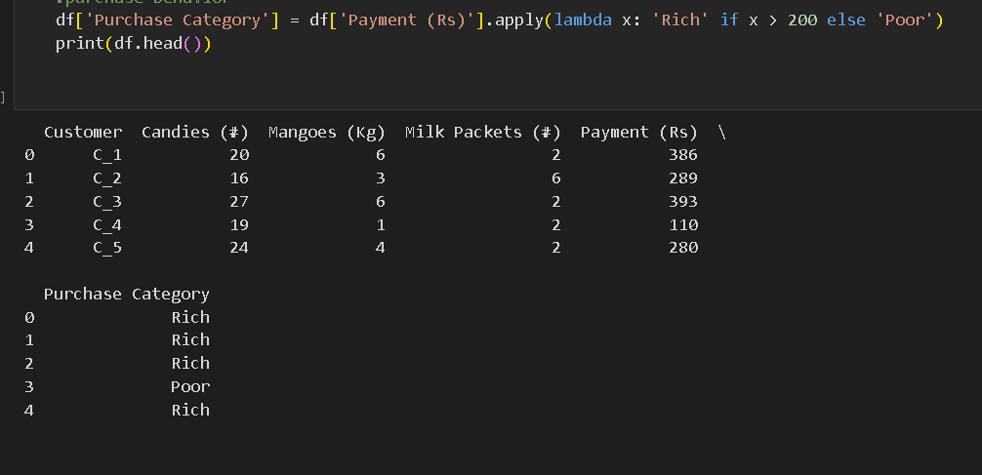

3.observing the stock data provided, record your suggestions to build a system that may be able to predict the price and change % in future.

* We can create new features that capture revelent information.
* We can clean the data by converting data type and handling the missing data.
* We can split the dataset into validation and training.
* We can implement the risk management strategies.
* We can keep the model updated with the new data so that it can easily adapt to the changing market condition.
* We can compare the performance of our predictive model against the market indices to access it.